whyImproving the Learning Experience of Indonesian Traditional Music Through Augmented Reality Technology

Falisha Kayleen Romansya Binus University Malang, Indonesia

[falisha.romansya@binus.ac.id](mailto:falisha.romansya@binus.ac.id)

***Abstract***

Indonesia has various kinds of very valuable cultural heritage, one of which is traditional musical instruments. There are many kinds of traditional Indonesian musical instruments, and each traditional musical instrument reflects the rich culture and diversity of tribes throughout the archipelago. Each musical instrument is not unique in terms of shape and sound but also has deep historical and cultural value. Traditional musical instruments should not only be viewed as relics of the past but also as valuable assets that must be protected and passed on to future generations. Every Indonesian citizen has the responsibility to preserve this cultural heritage. With AR, users will get an interactive and fun learning experience about several traditional musical instruments.

***Keywords***

Cultural, musical, instruments, traditional, AR.

1. Introduction

Indonesia has various kinds of very valuable cultural heritage, one of which is traditional musical instruments. There are many kinds of traditional Indonesian musical instruments, and each traditional musical instrument reflects the rich culture and diversity of tribes throughout the archipelago. Some examples of traditional Indonesian musical instruments include angklung, tifa, sasando, bonang, kolintang, and gendang. Each musical instrument is not unique in terms of shape and sound but also has deep historical and cultural value. However, as time goes by, traditional Indonesian musical instruments are becoming less and less known to the younger generation. Technological advances and globalization have made modern musical instruments increasingly popular and easily accessible so the existence of traditional musical instruments is increasingly being displaced. It is a shame that this musical instrument, which is a symbol of national identity and pride, is increasingly rarely known and fewer in number. Lack of public awareness about preserving traditional Indonesian musical instruments is one of the factors that influences this.

Traditional musical instruments should not only be viewed as relics of the past but also as valuable assets that must be protected and passed on to future generations. Every Indonesian citizen has the responsibility to preserve this cultural heritage. This is the background for us to create AR (Augmented Reality) with the theme of traditional musical instruments. The creation of AR with the theme of traditional Indonesian musical instruments has great potential to revive the interest of Indonesian people of all ages in Indonesia's cultural heritage. With AR, users will get

an interactive and fun learning experience about several traditional musical instruments.

1. GOALS

AR (Augmented Reality) with the theme of traditional Indonesian musical instruments was created with several objectives. First, we hope that with AR, Indonesian people's knowledge about traditional musical instruments will increase significantly. This AR technology allows users to view and interact with three-dimensional models of traditional musical instruments directly via their devices, such as phones or tablets. In this way, information regarding the shape, how to play, origins, and materials for making musical instruments can be presented in an interesting and easy-to-understand manner. In this way, Indonesia's cultural heritage in the form of traditional musical instruments remains known and preserved by all Indonesian people.

The second aim of developing AR is to raise the spirit of nationalism among the Indonesian people. By getting to know more about the richness of the nation's culture, it is hoped that the feeling of love and pride for Indonesia's cultural heritage will become stronger. It is hoped that AR can become an educational tool that is not only informative but also inspires all levels of Indonesian society so that it can trigger the desire to maintain and preserve the existence of traditional Indonesian musical instruments.

The third goal is to provide a fun and educational user experience. AR offers an interactive way of learning. Users can obtain various information about traditional Indonesian musical instruments, listen to the sound of the musical instrument in question, and test how much the user knows about traditional Indonesian musical instruments through quizzes. This AR can be used by all Indonesian people without any age restrictions so that AR not only functions as an educational tool but also as a means of entertainment for its users.

This AR was also created for users who don't know about Indonesian traditional musical instruments so that users who don't know anything at all are expected to know and be interested in using the culture of Indonesian traditional musical instruments.

1. Methodology

We created AR as the main object that will be used as an introduction to traditional Indonesian musical instruments. This AR includes

6 traditional Indonesian musical instruments, namely angklung, tifa, sasando, bonang, kolintang, and gendang. Each musical instrument displayed will contain information that includes the name of

the musical instrument, the region the musical instrument originates from, how to play the musical instrument, and what material the musical instrument is made of. In this AR, when the initial display is displayed it will show images of several musical instruments, so when the user selects a musical instrument, the scene on the initial display will move/direct according to the image of the musical instrument pressed or selected by the user, and will display several information that can be read regarding the musical instrument, and users can also listen to the sound of the musical instrument according to the type of musical instrument.

We started by using survey research methods. We surveyed using a Google form to get feedback on our use of AR. which in our survey contains a video of our use of AR along with an explanation. Based on the survey we got, 90% said that AR was fun, easy to understand, and simple, but too monotonous, unmotivated, confusing, and not very attractive.

What we can take away is that many people are not yet interested in AR, but how do we introduce this musical instrument, fix what parts are lacking for users, and make it as attractive as possible?

The following is an AR that we created to introduce traditional Indonesian musical instruments.

This is the main menu.

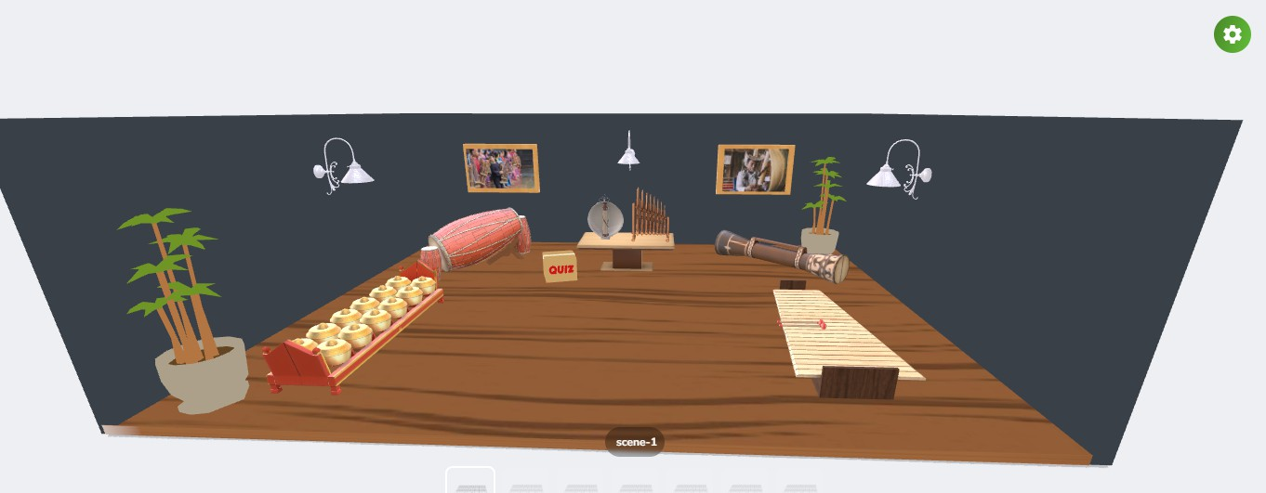

This is the display when the user selects one of the musical instrument images

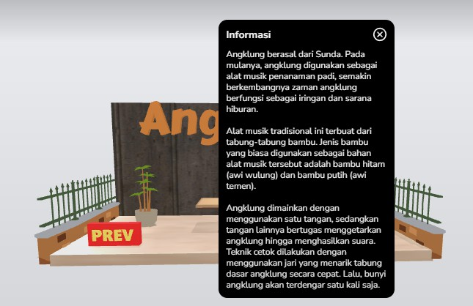

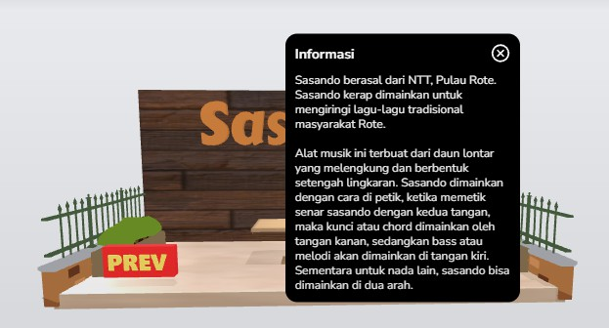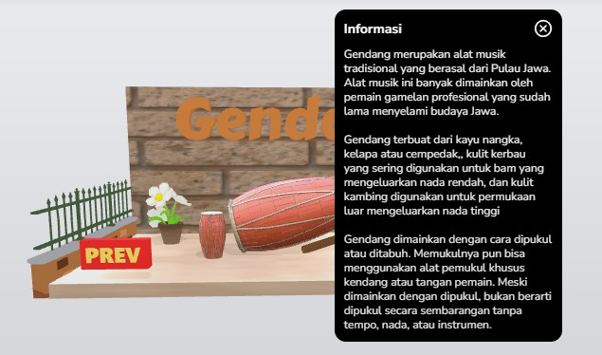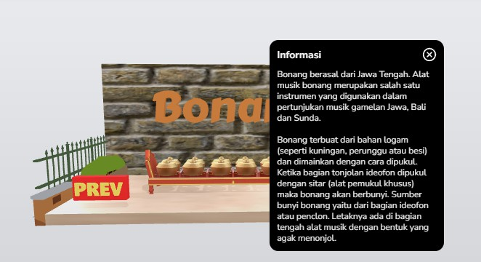

This is an example of a quiz display, when the answer is correct then it will look like this

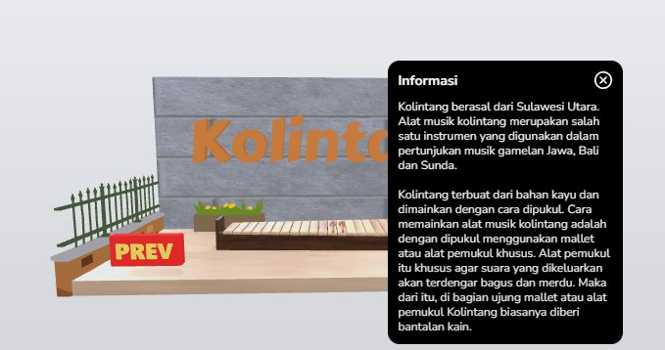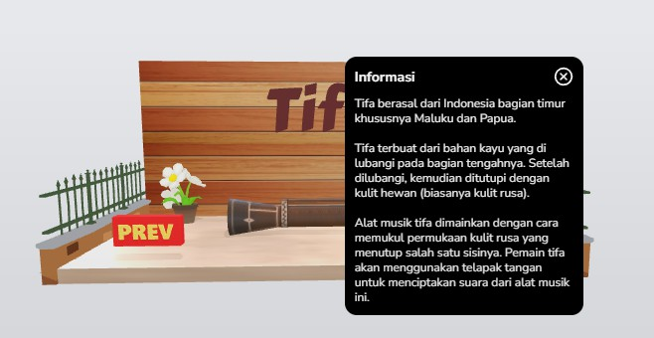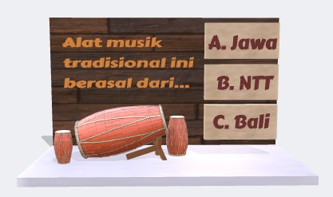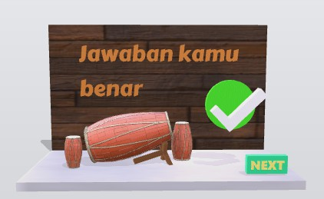

When the answer is wrong, it will look like this.

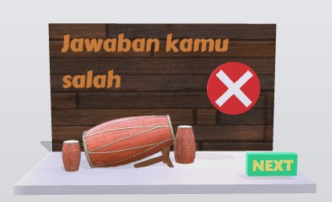Likewise with other traditional musical instruments.

Developing an Augmented Reality (AR) application on traditional Indonesian musical instruments can be a solution in introducing the culture of traditional Indonesian musical instruments by providing new knowledge and hopefully being able to preserve traditional Indonesian musical instruments. Therefore, traditional music has significant cultural value, we play a very important role in preserving this culture.

1. Results

Conclusion

References

1. Haryani, P., & Triyono, J. (2017). Augmented Reality (AR) sebagai teknologi interaktif dalam pengenalan benda cagar budaya kepada masyarakat. Jurnal SIMETRIS, 8(2), 807-812. ISSN: 2252-4983.
2. Ratu. (2019). Semakin punahnya alat musik tradisional di era milenial. *Kompasiana*.

[https://www.kompasiana.com/ratu83030/5d103dd8097f3632163fdfb2](https://www.kompasiana.com/ratu83030/5d103dd8097f3632163fdfb2/semakin-punahnya-alat-musik-tradisional-di-era-milenial)

[/semakin-punahnya-alat-musik-tradisional-di-era-milenial](https://www.kompasiana.com/ratu83030/5d103dd8097f3632163fdfb2/semakin-punahnya-alat-musik-tradisional-di-era-milenial)